The arrangement of flowers on the floral axis is termed as
A. Inflorescence
B. Aestivation
C. Placentation
D. Phyllotaxy
ANSWER: A
Depending upon the arrangement of the flower, the inflorescence is classified as:
A. Racemose
B. Cymose
C. Compound
D. All of these
ANSWER: D
The main axis in ____________inflorescence continues to grow and produce flowers laterally
A. Racemose
B. Cymose
C. Both A and B
D. None of these
ANSWER: A
The main axis in ___________inflorescence has limited growth, which later terminates into a flower.
A. Racemose
B. Cymose
C. Both A and B
D. None of these
ANSWER: B
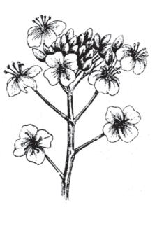
The inflorescence of mustard is:
A. Raceme
B. Spike
C. Catkin
D. All of these
ANSWER: A
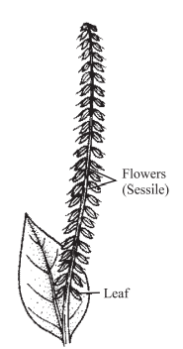

The inflorescence of Achyranthes is:
A. Raceme
B. Spike
C. Catkin
D. All of these
ANSWER: B
_________ is the inflorescence in the mulberry
A. Raceme
B. Spike
C. Catkin
D. All of these
ANSWER: C
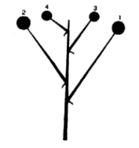
Identify the inflorescence
A. Umbel
B. Spadix
C. Corymb
D. Catkin
ANSWER: C
Iberis amara inflorescence
A. Umbel
B. Spadix
C. Corymb
D. Catkin
ANSWER: C
Inflorescence is
A. the arrangement of the flowers on a plant
B. a prolonged cold period – winter – to promote flowering
C. the ability of plants to measure environmental day length
D. none of these
ANSWER: A
Racemose Inflorescence is found in the inflorescence of
A. radish
B. mustard
C. Both A and B
D. None of these
ANSWER: C
In mulberry, the inflorescence is
A. Catkin
B. Capitulum
C. Spadix
D. Cyathium
ANSWER: A
Cymose inflorescence is
A. Definite
B. Indefinite
C. Verticillate
D. Alternate
ANSWER: A
Indeterminate simple inflorescences are generally called
A. Racemose
B. Cymose
C. Both A and B
D. None of these
ANSWER: A
Determinate simple inflorescences are generally called
A. Racemose
B. Cymose
C. Both A and B
D. None of these
ANSWER: B

